**Experiment Title – 3.2**

**Student Name:** YANA SRIVASTAVA **UID:** 20BCS2279

**Branch:** BE-CSE **Section/Group:** 20BCS-WM-905/A

**Semester:** 5th  **Subject Code:** 21 CSP-321

**Subject Name:** PBLJ LAB

**1. Aim:** Create a Servlet/ application with a facility to print any message on web browser.

.

**2. Software/Hardware Requirements:** VS Code or Eclipse

**3. Algorithm/ PsuedoCode:**

STEP 1: Create a index.jsp file in a webapp directory.

STEP 2: Create a package named as fun and create a java file named as functions.java.

STEP 3: functions.java file contains the logic for checking the validation in the form of submitting.

STEP 4: At Last start the server and display the output on the web browser.

STEP 5: EXIT.

**CODE:**

***Index.jsp***

<%@ page language=*"java"* contentType=*"text/html; charset=ISO-8859-1"*

pageEncoding=*"ISO-8859-1"*%>

<!DOCTYPE html>

<html>

<head>

<meta charset=*"ISO-8859-1"*>

<title>Insert title here</title>

<style>

**h1**{

margin: *auto*;

width: *60%*;

padding-left: *100px*;

}

**body** {

background:*orange*;

color: *white*;

}

*.fall* {

background: *grey*;

color: *white*;

border: *2px solid blue*;

width: *45%*;

margin:*auto*;

}

*.input-group*{

position: *relative*;

margin: *23px*;

left: *175px*;

}

**button**{

position: *relative*;

left: *35%*

}

**button***:hover*{

cursor:*pointer*;

background: *black*;

color: *white*;

}

**h3**{

margin: *auto*;

width: *40%*;

padding: *5px*;

}

</style>

</head>

<body>

<h1>Welcome the AP Auctions, Please Enter the Bid</h1>

<form class=*"fall"* name=*"register_form"* action=*"*<%=request.getContextPath()%>*/functions"* method=*"post"* >

<div class=*"input-group mb-2"*>

<input type=*"text"*name=*"name"* id=*"name"* onkeypress="return /[0-9a-zA-Z]/i.test(event.key)" class=*"form-control input_user"* required=*"required"*

placeholder=*"Item ID"*>

</div>

<p class=*"error"* id=*"name_id"*></p>

<div class=*"input-group mb-2"*>

<div class=*"input-group-append"*>

<span class=*"input-group-text"*><i class=*"fas fa-user"*></i></span>

</div>

<input type=*"text"* name=*"branch"* id=*"branch"* onkeypress="return /[0-9a-zA-Z]/i.test(event.key)" class=*"form-control input_user"* required=*"required"*

placeholder=*"Item Name"*>

</div>

<p class=*"error"* id=*"branch_id"*></p>

<div class=*"input-group mb-2"*>

<div class=*"input-group-append"*>

<span class=*"input-group-text"*><i class=*"fas fa-user"*></i></span>

</div>

<input type=*"text"* name=*"course"* id=*"course"* onkeypress="return /[0-9a-zA-Z]/i.test(event.key)" class=*"form-control input_user"* required=*"required"*

placeholder=*"Your Name"*>

</div>

<p class=*"error"* id=*"course_id"*></p>

<div class=*"input-group mb-2"*>

<div class=*"input-group-append"*>

<span class=*"input-group-text"*><i class=*"fas fa-user"*></i></span>

</div>

<input type=*"email"* name=*"email"* id=*"email"*onkeypress="return /[0-9a-zA-Z.@_]/i.test(event.key)" class=*"form-control input_user"* required=*"required"*

placeholder=*"Email"*>

</div>

<p class=*"error"* id=*"email_id"*></p>

<div class=*"input-group mb-2"*>

<div class=*"input-group-append"*>

<span class=*"input-group-text"*><i class=*"fas fa-user"*></i></span>

</div>

<input type=*"number"* id=*"number"* onKeyPress="if(this.value.length==10) return false;" name=*"number"* class=*"form-control input_user"* required=*"required"*

placeholder=*"Amount Bid"*>

</div>

<p class=*"error"* id=*"number_id"*></p>

<button type=*"submit"* onclick=hide()>Submit Bid</button>

</form>

<script>

document.getElementById("name").addEventListener("keypress", myname);

document.getElementById("name").addEventListener("mouseover", myname);

**function** myname() {

**var** name= document.register_form.name.value;

**var** paragraph = document.getElementById("name_id");

**if**(name.length==0){

paragraph.textContent="Please enter your Id !!";

document.register_form.name.focus();

}

**if**(name.length>5 && name.length!=0){

paragraph.textContent="\ID should not be greater than 5 character !!!";

document.register_form.name.focus();

}

**if**(name.length<5){

paragraph.textContent="";

}

}

document.getElementById("email").addEventListener("keypress", myemail);

document.getElementById("email").addEventListener("mouseover", myemail);

**function** myemail() {

**var** email= document.register_form.email.value;

**var** paragraph = document.getElementById("email_id");

**if**(email.length==0){

paragraph.textContent="Please enter your email !!";

document.register_form.email.focus();

}

**else** **if**(!(/^\w+([\.-]?\w+)*@\w+([\.-]?\w+)*(\.\w{2,3})+$/.test(email))){

paragraph.textContent="Enter valid email !!!";

document.register_form.email.focus();

}

**else**{

paragraph.textContent="";

}

}

document.getElementById("branch").addEventListener("keypress", mybranch);

document.getElementById("branch").addEventListener("mouseover", mybranch);

**function** mybranch() {

**var** branch= document.register_form.branch.value;

**var** paragraph = document.getElementById("branch_id");

**if**(branch.length<1){

paragraph.textContent="Please enter your Item Name !!";

document.register_form.branch.focus();

}

**else**{

paragraph.textContent="";

}

}

document.getElementById("course").addEventListener("keypress", mycourse);

document.getElementById("course").addEventListener("mouseover", mycourse);

**function** mycourse() {

**var** course= document.register_form.course.value;

**var** paragraph = document.getElementById("course_id");

**if**(course.length<1){

paragraph.textContent="Please enter your Name !!";

document.register_form.course.focus();

}

**else**{

paragraph.textContent="";

}

}

document.getElementById("number").addEventListener("keypress", mynumber);

document.getElementById("number").addEventListener("mouseover", mynumber);

**function** mynumber() {

**var** number= document.register_form.number.value;

**var** paragraph = document.getElementById("number_id");

**if**(number.length==0){

paragraph.textContent="Please enter your Amount Bid !!";

document.register_form.email.focus();

}

**else** **if**(!(/^[6-9]\d{9}$/.test(number))){

paragraph.textContent="Enter valid Amount Bid !!!";

document.register_form.number.focus();

}

**else**{

paragraph.textContent="";

}

}

</script>

<h3>Bid Submitted</h3>

<h3>Your bid is now active. if your bid is successful, you will be notified within 24HRS</h3>

<h3> Item id: <%=request.getAttribute("ans") %></h3> <br>

<h3> Item Name: <%=request.getAttribute("ans1") %></h3> <br/>

<h3> Your Name <%=request.getAttribute("ans2") %></h3><br/>

<h3> Email:<%=request.getAttribute("ans3") %></h3><br/>

<h3> Your Amount: <%=request.getAttribute("ans4") %></h3><br/>

</body>

</html>

***Functions.java***

package fun;

import java.util.*;

import java.io.IOException;

import java.io.PrintWriter;

import javax.servlet.ServletException;

import javax.servlet.annotation.WebServlet;

import javax.servlet.http.HttpServlet;

import javax.servlet.http.HttpServletRequest;

import javax.servlet.http.HttpServletResponse;

/**

* Servlet implementation class functions

*/

@WebServlet(name="functions",urlPatterns={"/functions"})

public class functions extends HttpServlet {

protected void doPost(HttpServletRequest request, HttpServletResponse response) throws ServletException, IOException {

String a=request.getParameter("name");

String b=request.getParameter("branch");

String c=request.getParameter("course");

String d=request.getParameter("email");

String e=request.getParameter("number");

try {

String ans=a;

String ans1=b;

String ans2=c;

String ans3=d;

String ans4=e;

request.setAttribute("ans",ans);

request.setAttribute("ans1",ans1);

request.setAttribute("ans2",ans2);

request.setAttribute("ans3",ans3);

request.setAttribute("ans4",ans4);

request.getRequestDispatcher("index.jsp").forward(request,response);

}catch(Exception e1) {

System.out.println(e1);

}

}

}

**OUTPUT:**

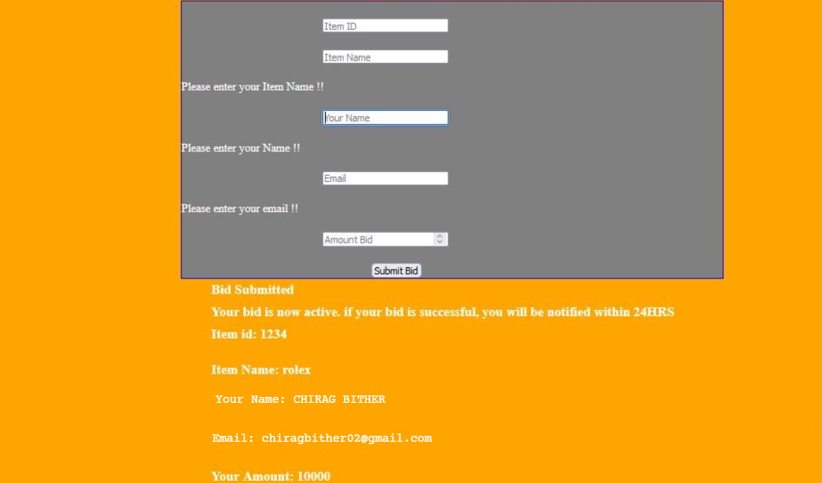

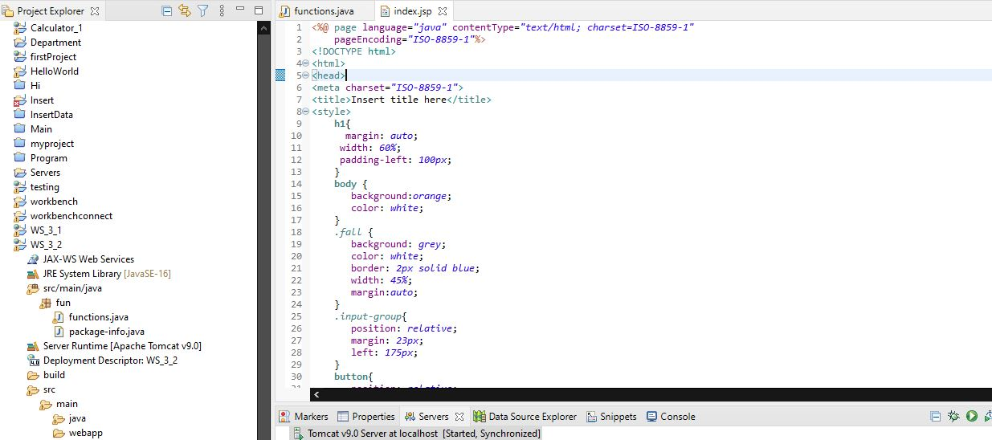

**Learning outcomes (What I have learnt):**

1. Learn About the servlet.
2. Learn about jsp and dynamic web project.
3. Learn about the tomcat server and its integrations with the java.